**22AIE457**

**FULL STACK DEVELOPMENT**

**LAB REPORT**

**PRAGHAADEESH R**

**CH.EN.U4AIE21035**

**LAB-1**

**AIM :**

To install Git and work with basic Git commands.

**PROCEDURE :**

**Installation :**

****Go to <https://git-scm.com/downloads/win> and download git for windows.

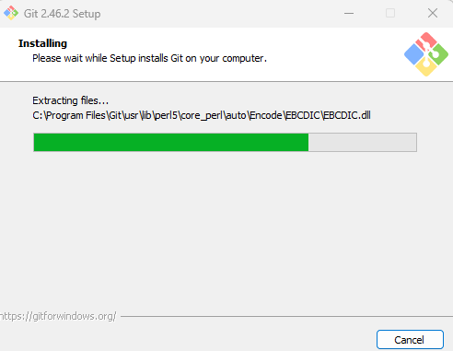Open the installer and give the necessary configuration and wait for Git to be installed.

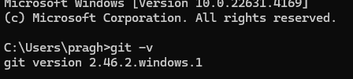Verify installation by entering “git -v” command in terminal.

**Git Commands :**

1. **git init :**
2. 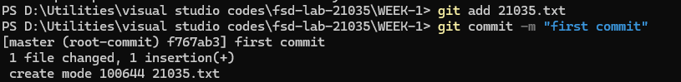**git add & commit :**
3. 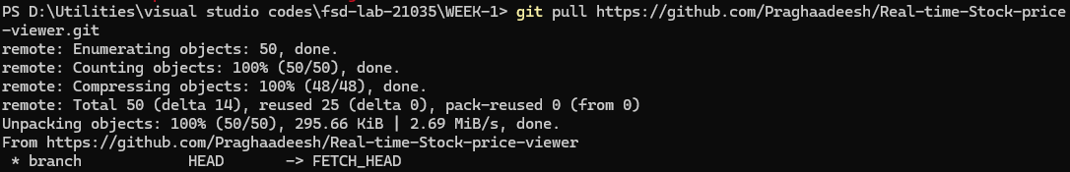**git pull :**
4. 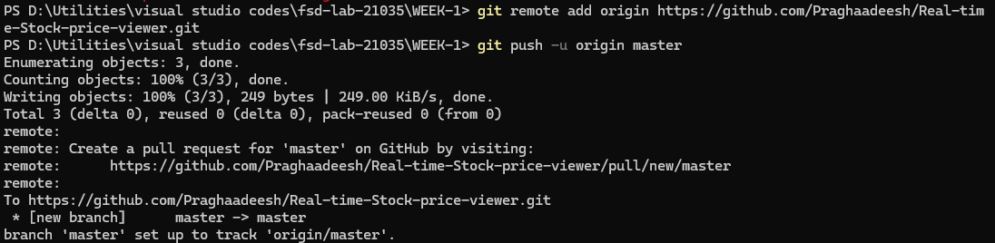**git push :**

**RESULTS :**

Thus, Git has been successfully installed and basic git commands have been tested and the output is verified.

**LAB-2**

**AIM :**

To work with nodejs basics and use various HTML tags.

**PROCEDURE :**

**CODE :**

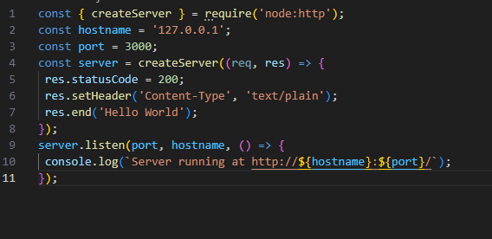 **Creating a basic nodejs server :**

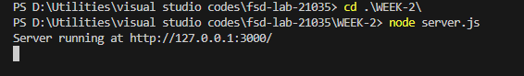 **OUTPUT :**

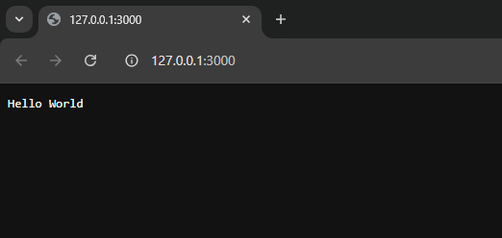

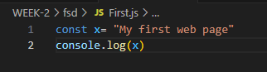 **Using console log :**

** OUTPUT :**

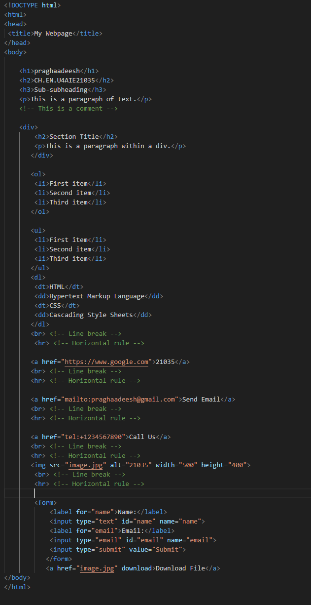 **HTML Tags :**



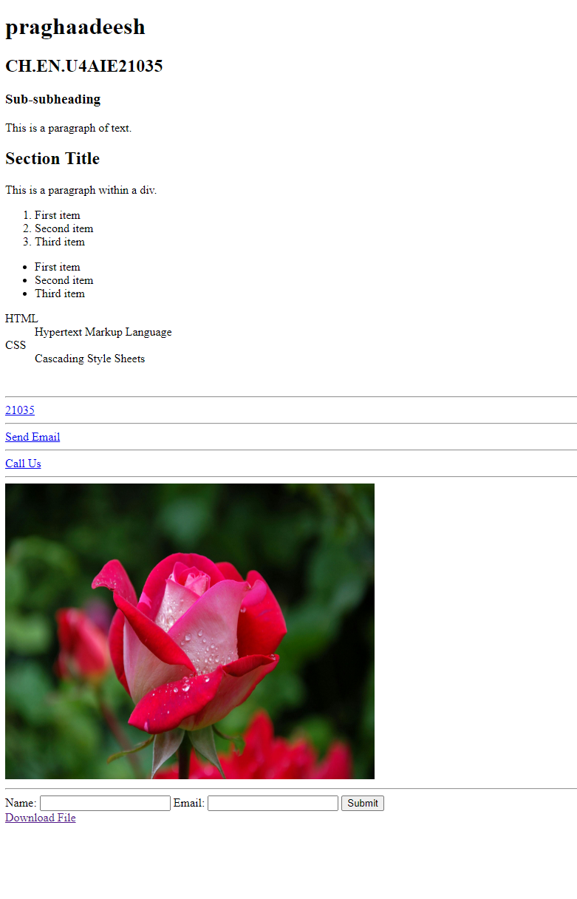 **OUTPUT :**

**RESULT :**

Thus, basics of nodejs and various HTML tags have been tried and the output is verified.

**LAB-3**

**AIM :**

To use HTML and CSS media queries to make a webpage responsive.

**PROCEDURE :**

1. **HTML Viewport meta tag for Responsive Web Design**

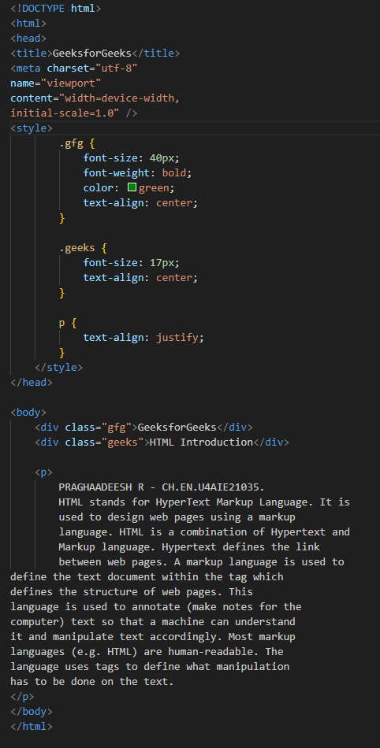**CODE :**

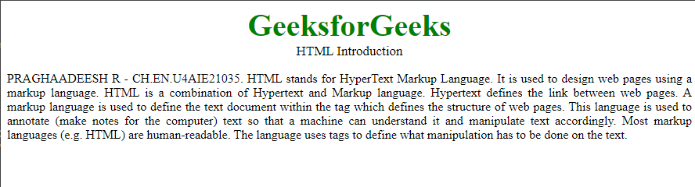**OUTPUT :**

1. **Responsive Images**
   1. **Using width Property**

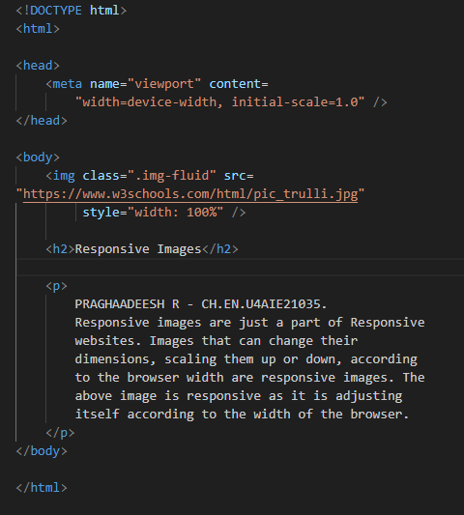 **CODE :**

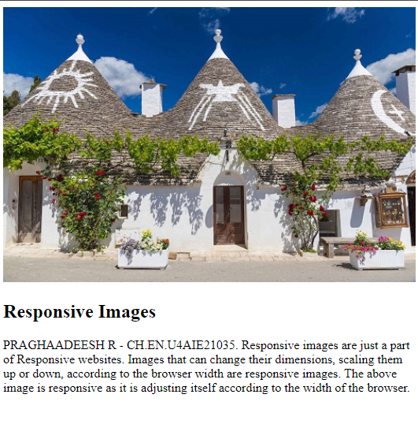**OUTPUT :**

* 1. **Using the max-width Property**

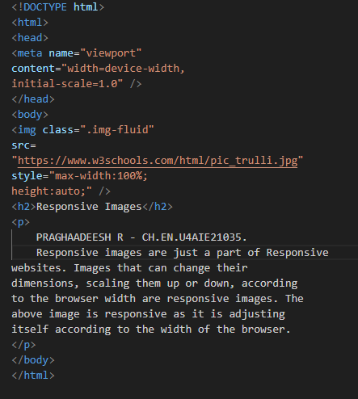**CODE :**

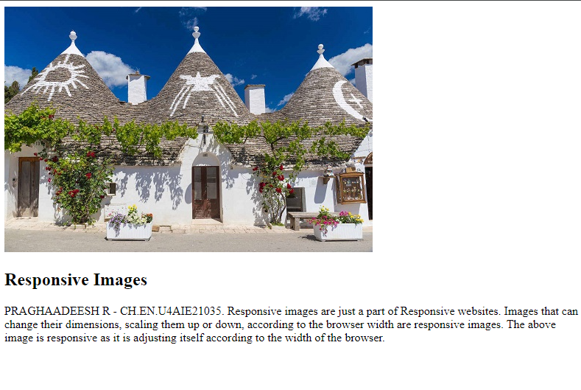**OUTPUT :**

* 1. **Responsive Image for different Browser Width**

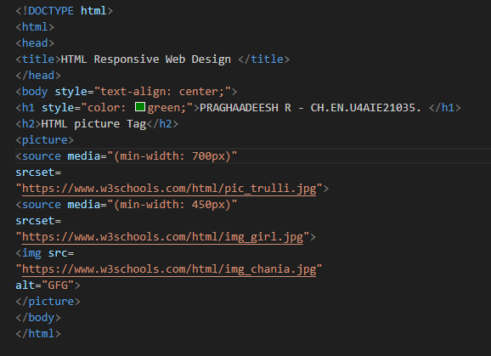 **CODE :**

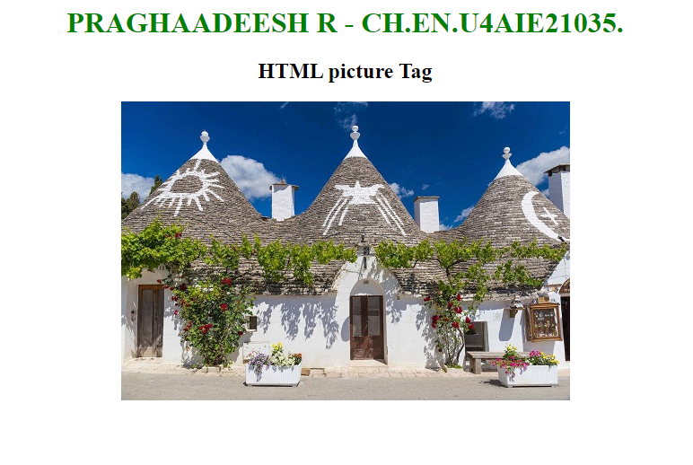**OUTPUT :**

1. **Responsive Texts**

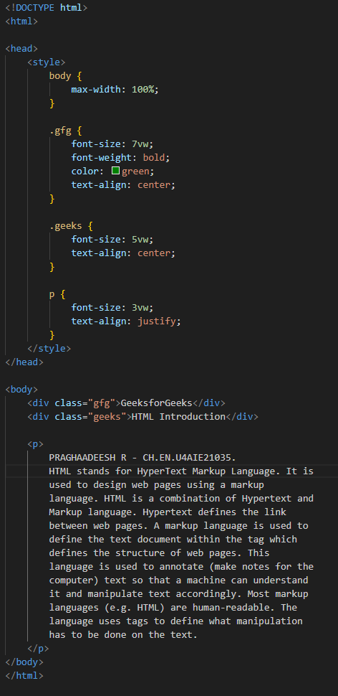 **CODE :**

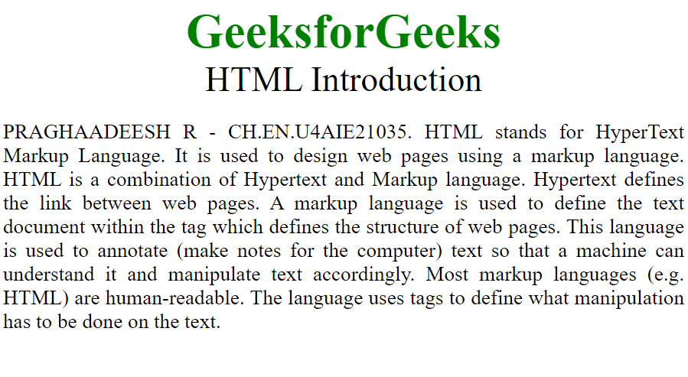**OUTPUT :**

1. **CSS media Queries**

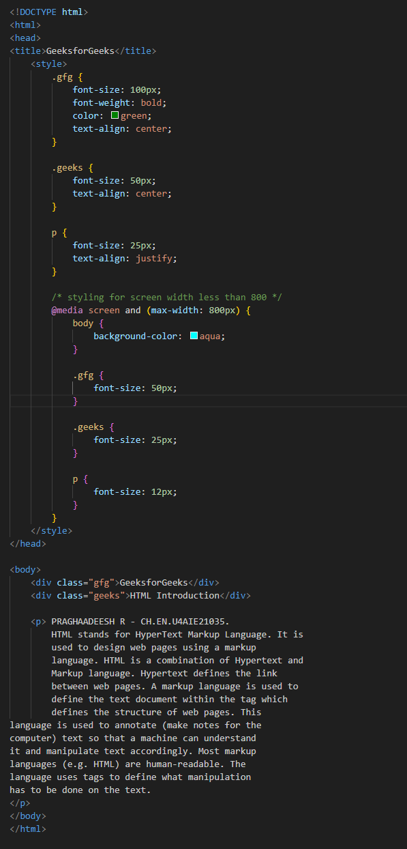 **CODE :**

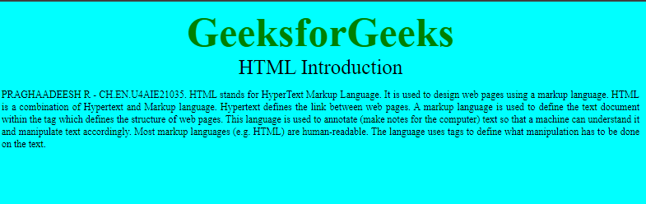**OUTPUT :**

1. **Responsive Layouts**

**5.1 Using flexbox property**

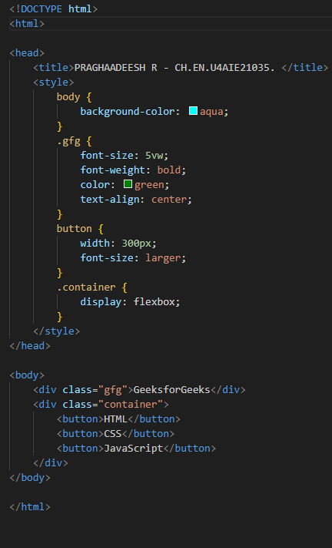 **CODE :**

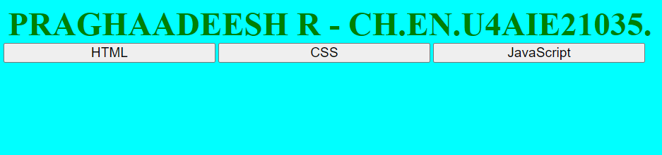**OUTPUT :**

**5.2 Using CSS Grids**

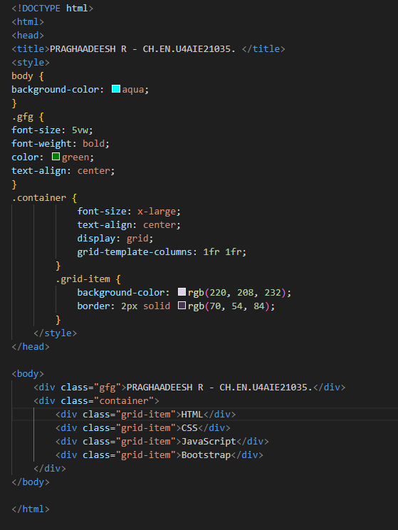 **CODE :**

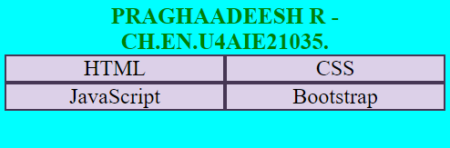**OUTPUT :**

**5.3 Using CSS Multi-Column**

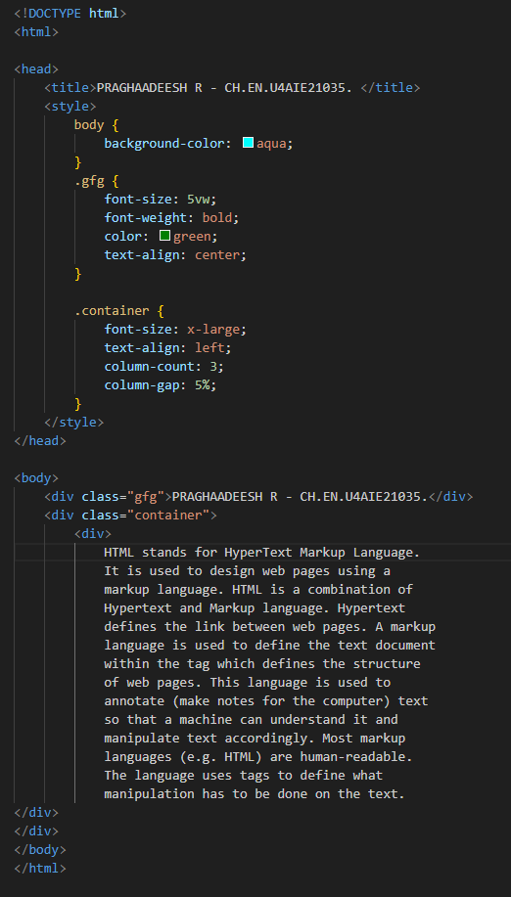 **CODE :**

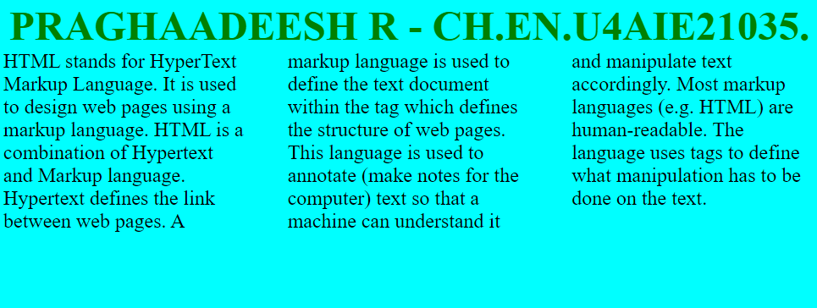**OUTPUT :**

**RESULT :**

Thus, responsive webpage techniques have been explored and CSS media queries have been executed.

**LAB-4**

**AIM :**

To create a comprehensive Bootstrap Web Page using HTML.

**PROCEDURE :**

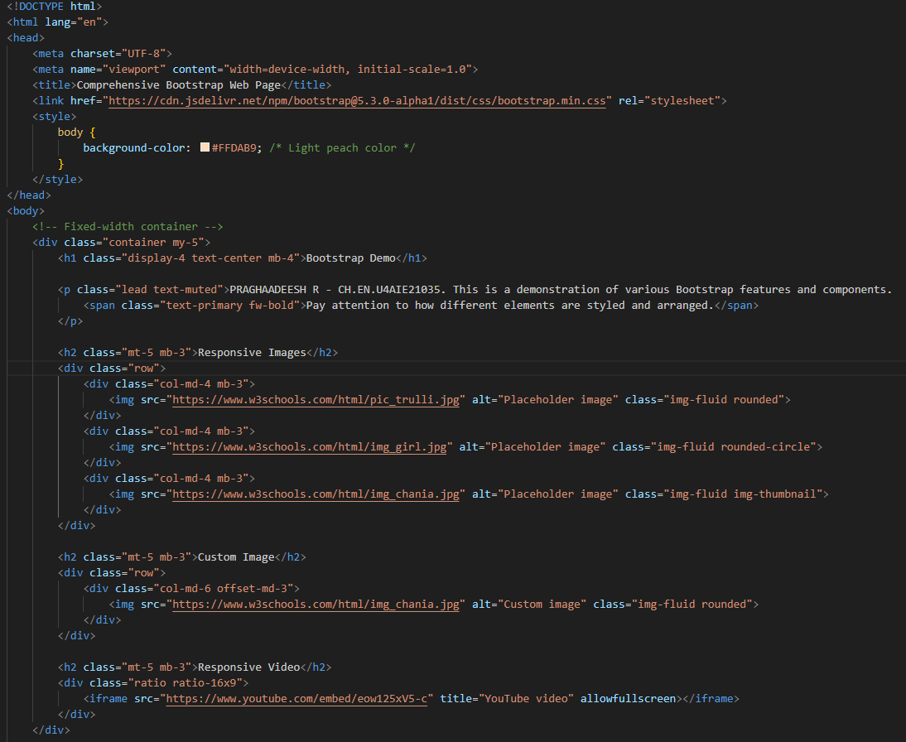 **CODE :**

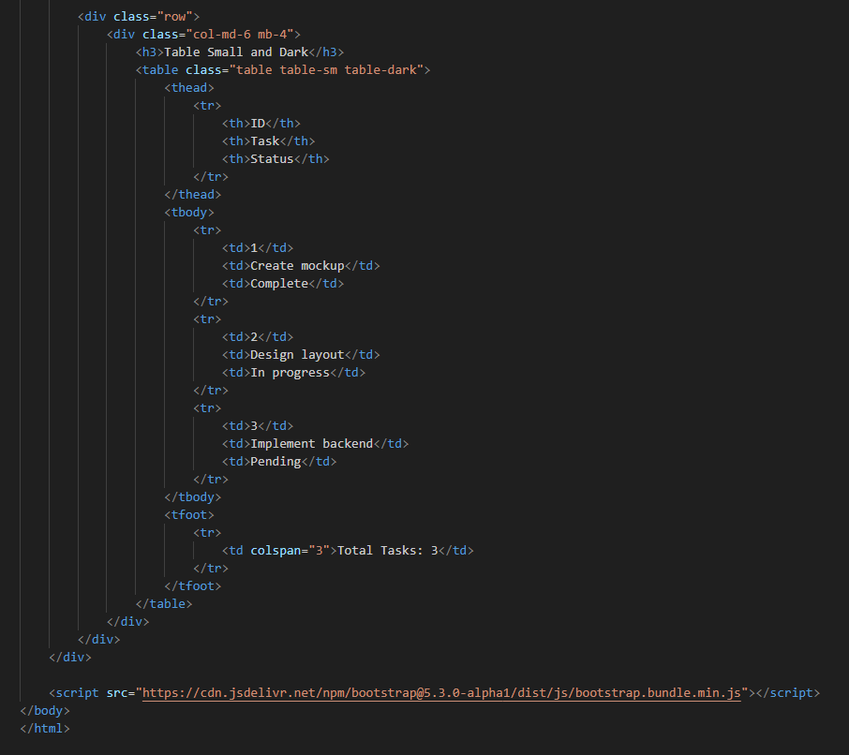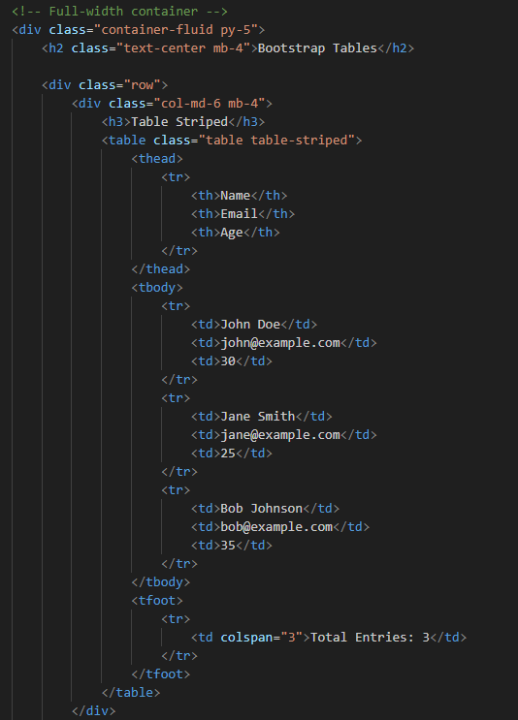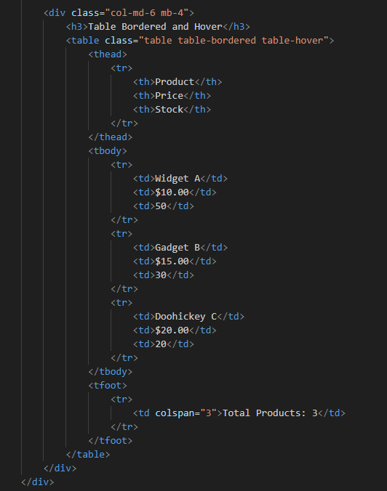

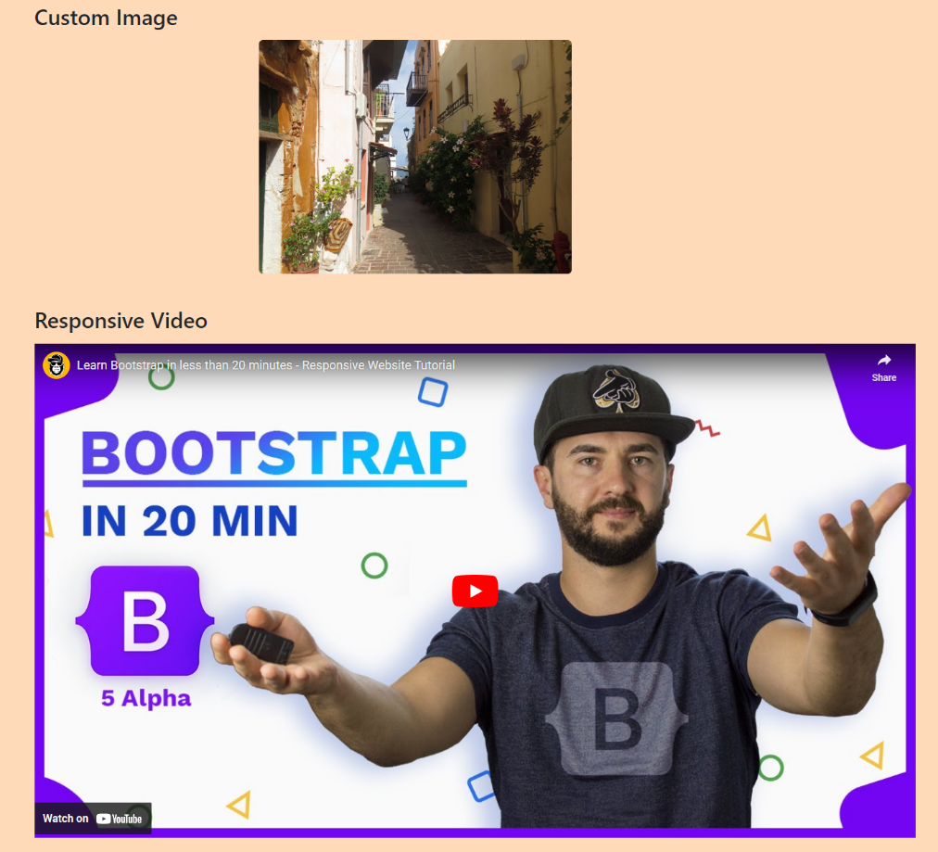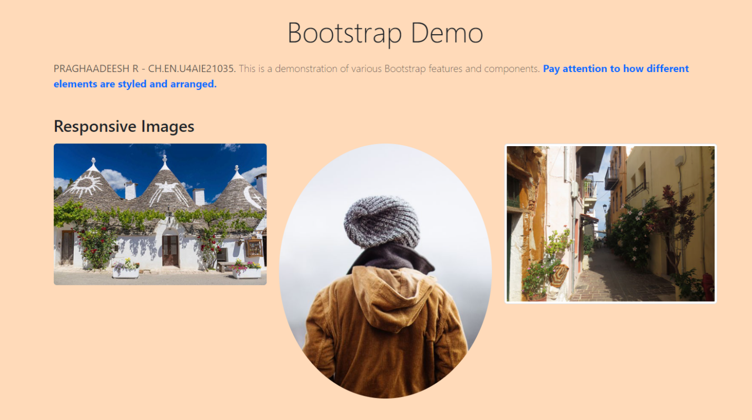**OUTPUT :**

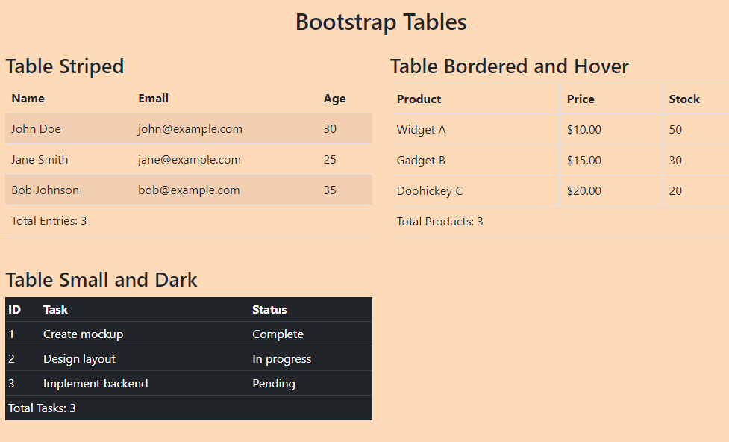

**RESULT :**

Thus, a responsive bootstrapped webpage has been created using HTML, which contains responsive images, custom images, responsive video and bootstrap tables.

**LAB-5**

**AIM :**

To write javascript program to perform certain tasks.

**PROCEDURE :**

1. **Write a JavaScript program to compute the sum of an array of integers**

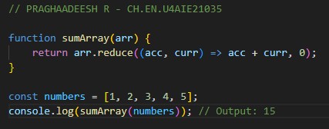 **CODE :**

 **OUTPUT :**

1. **Write a JavaScript program to determine whether a given year is a leap year in the Gregorian calendar**

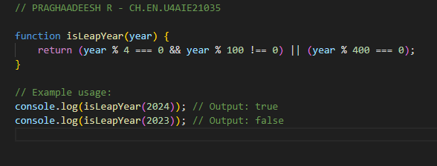 **CODE :**

 **OUTPUT :**

1. **Write a JavaScript function that checks whether a passed string is**

**palindrome or not**

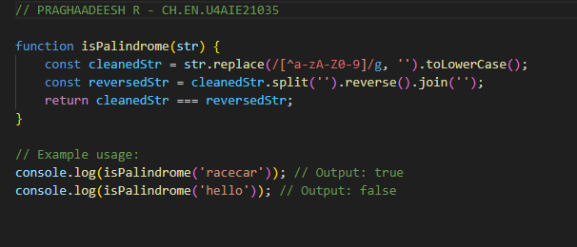**CODE :**

**OUTPUT :**

1. **Write a JavaScript program to test the first character of a string is**

**uppercase or not**

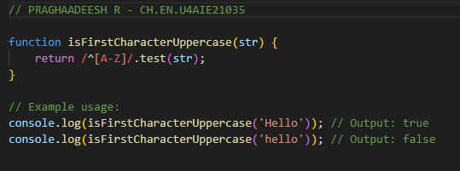 **CODE :**

**OUTPUT :**

1. **Write a JavaScript program to set the background colour of a**

**Paragraph**

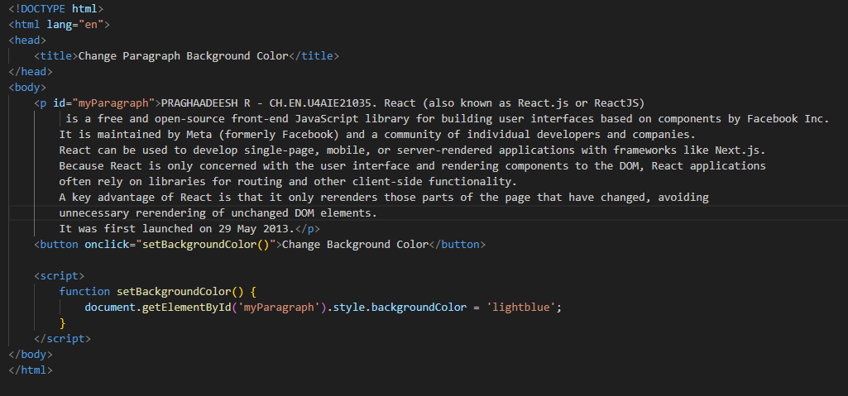 **CODE :**

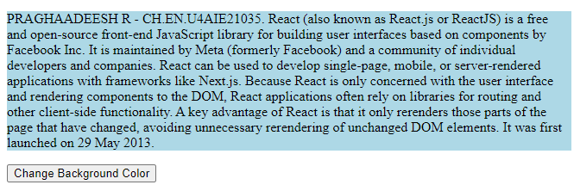 **OUTPUT :**

1. **Write a JavaScript program to check the given number is mobile**

**number or not using form**

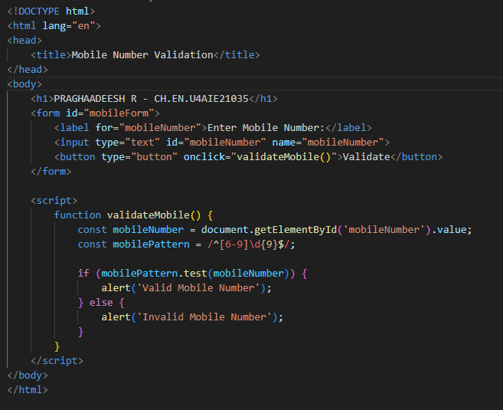 **CODE :**

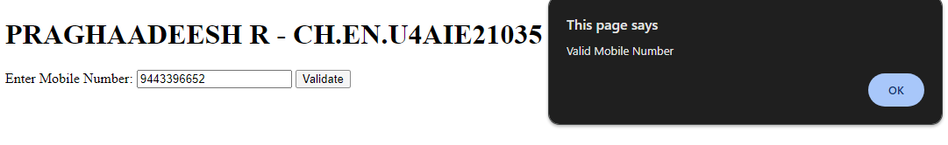**OUTPUT :**

1. **Design a student registration form and apply validation on it by using**

**external javascript.**

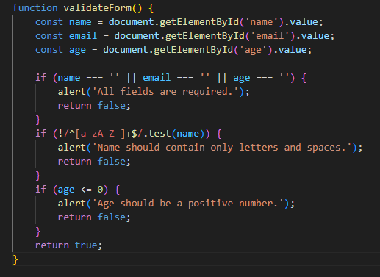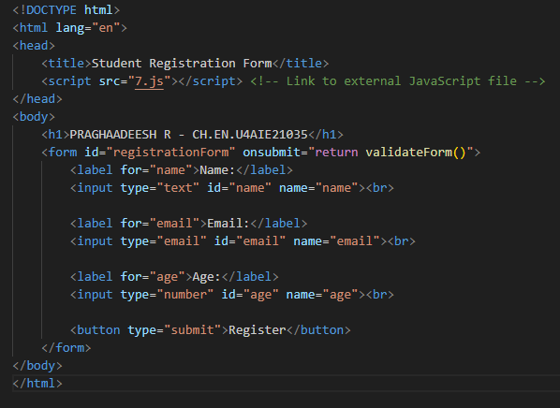 **CODE :**

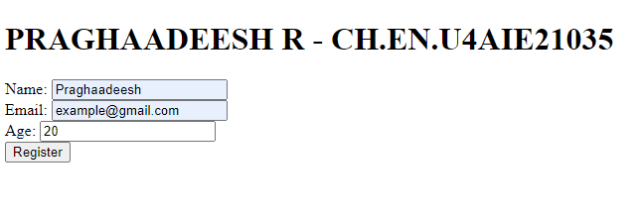**OUTPUT :**

1. **Design a simple Calculator by using html, css, and javascript**

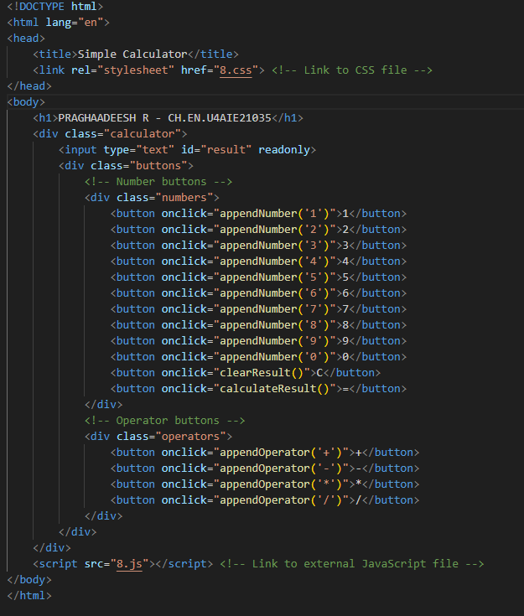**CODE :**

**HTML :**

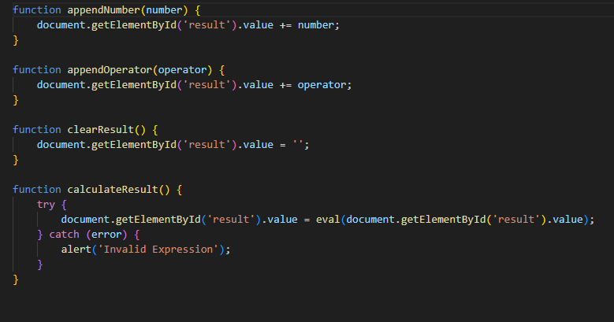**JAVASCRIPT :**

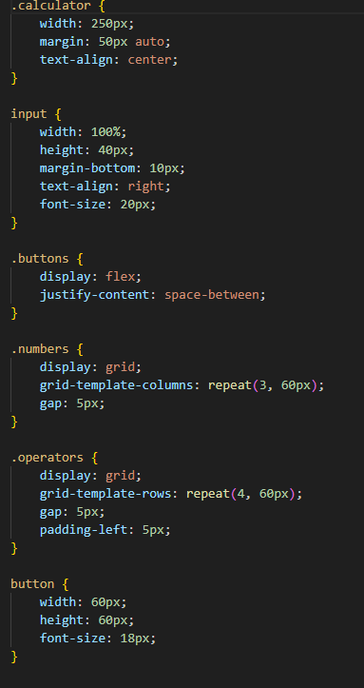**CSS :**

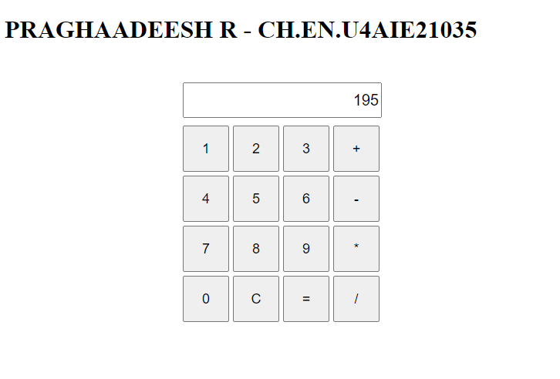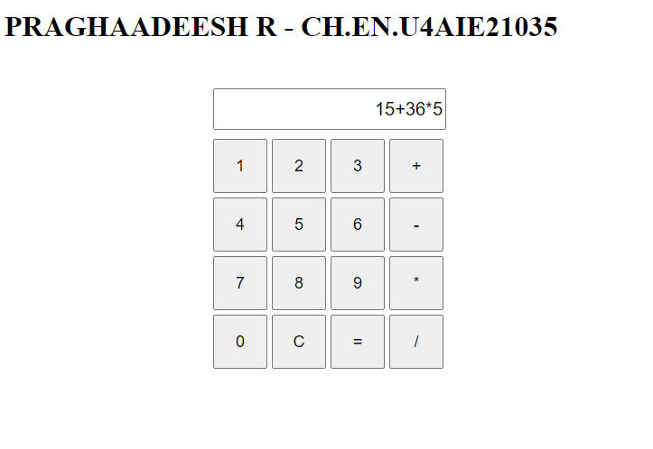**OUTPUT :**

**RESULT :**

Thus, javascript programs to perform various tasks has been created and the output has been verified.

**LAB-6**

**AIM :**

To create a login form using Node JS and MongoDB.

**PROCEDURE :**

**CODE :**

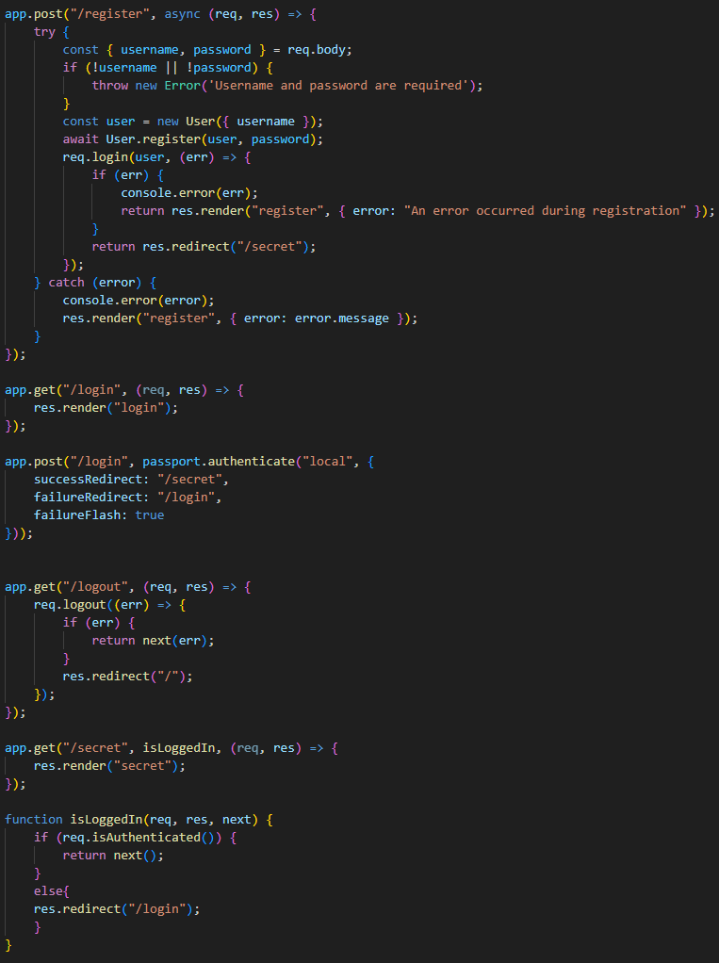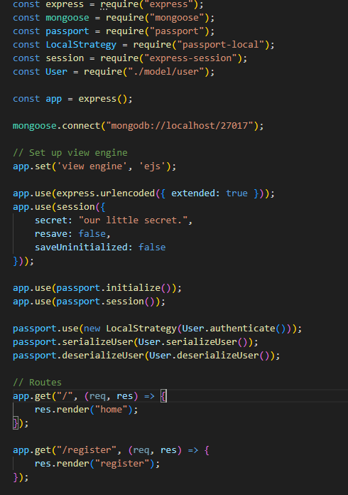 **App.js :**

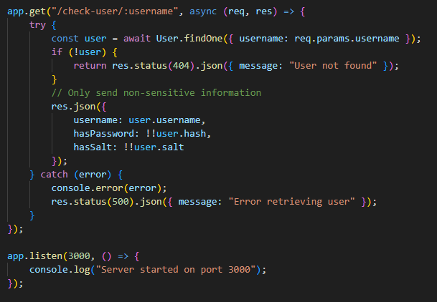

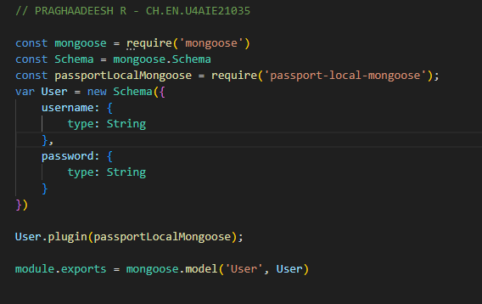 **User.js :**

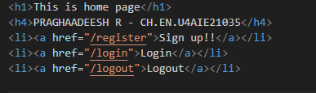 **Home.js :**

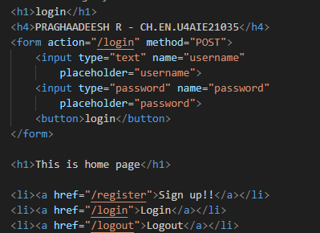 **Login.js :**

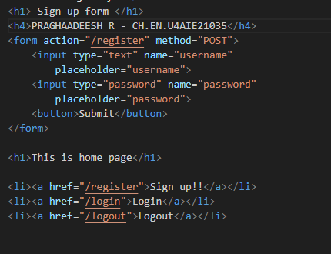 **Register.js :**

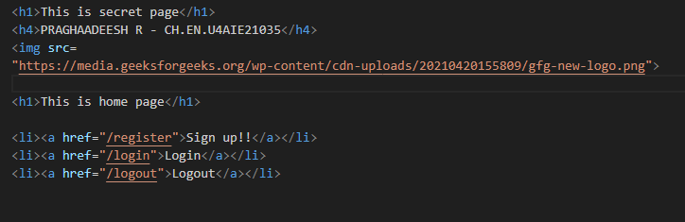 **Secret.js :**

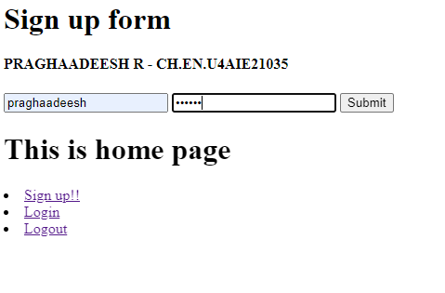 **OUTPUT :**

**RESULT :**

Thus, a login page has been created using Nodejs and MongoDB, and the login functionality has been verified.

**LAB-7**

**AIM :**

To create a Basic Login System with Node.js, Express, and MySQL

**PROCEDURE :**

**CODE :**

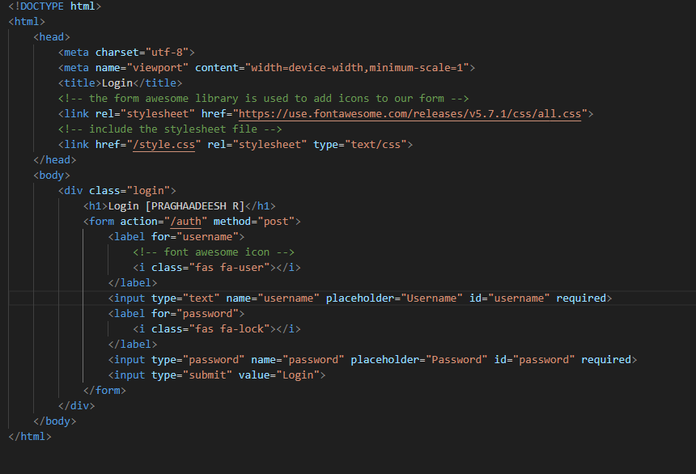 **HTML :**

 **JAVASCRIPT :**

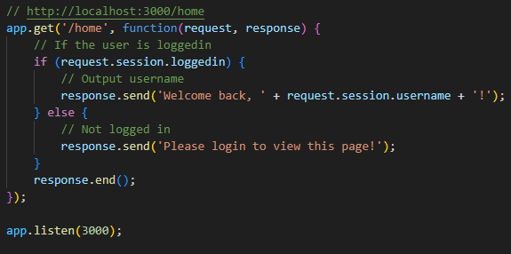

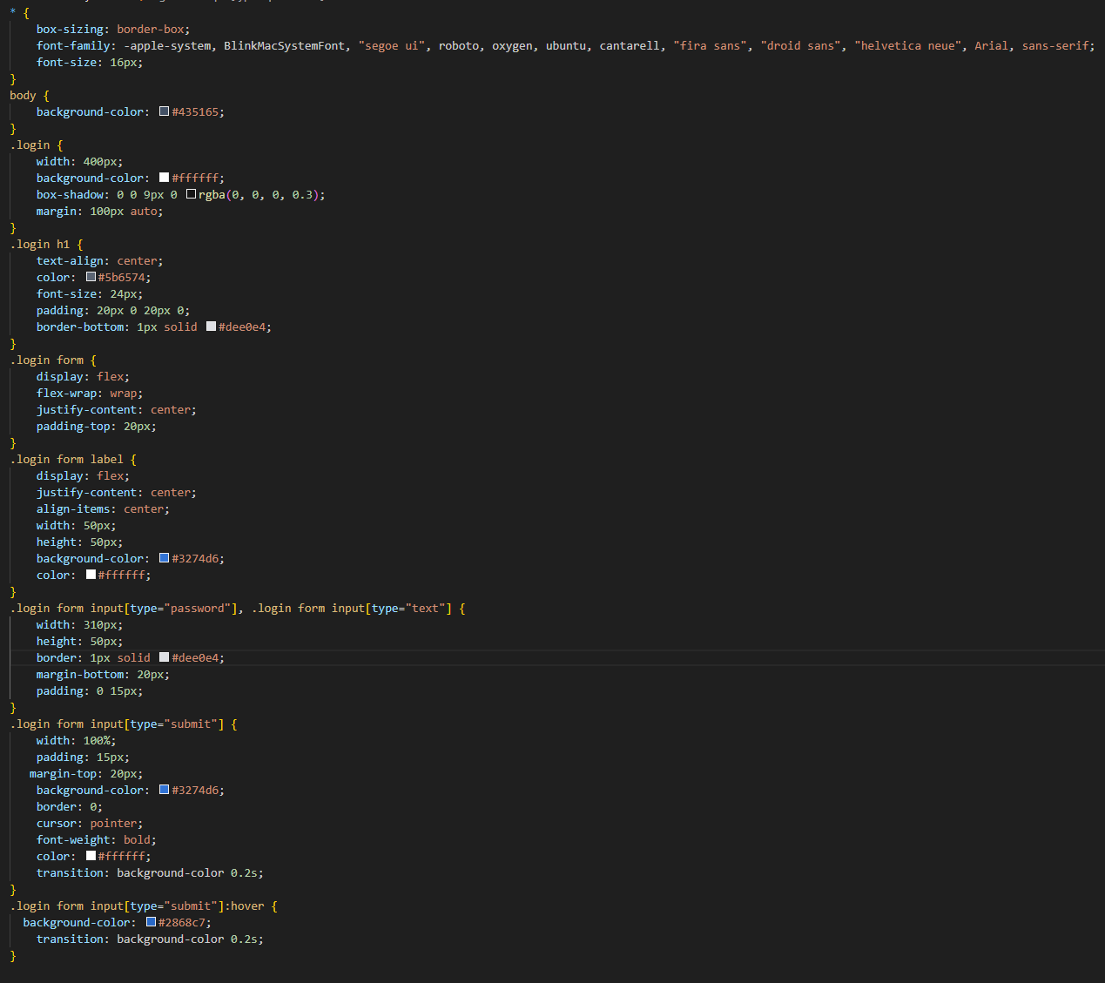 **CSS :**

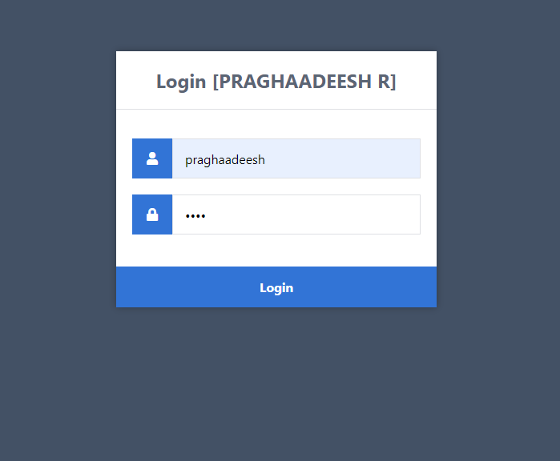**OUTPUT :**

**RESULT :**

Thus, a Basic Login System with Node.js, Express, and MySQL has been created and the functionalities has been verified.

**LAB-8**

**AIM :**

To Create a Live Editable Table with jQuery, PHP and MySQL

**PROCEDURE :**

**CODE :**

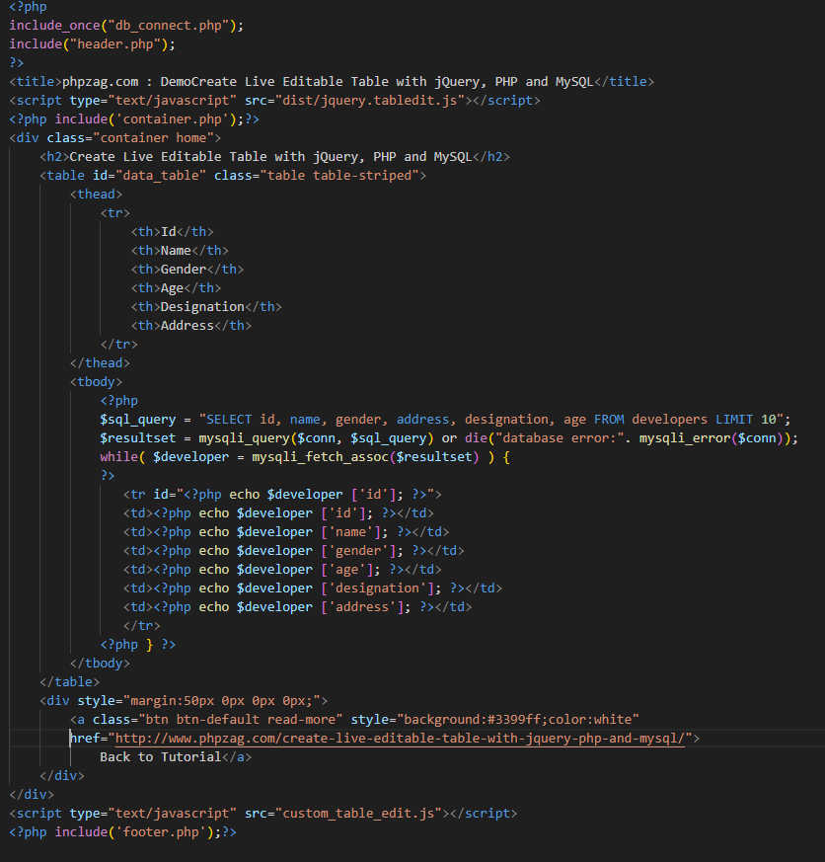 **Index.php :**

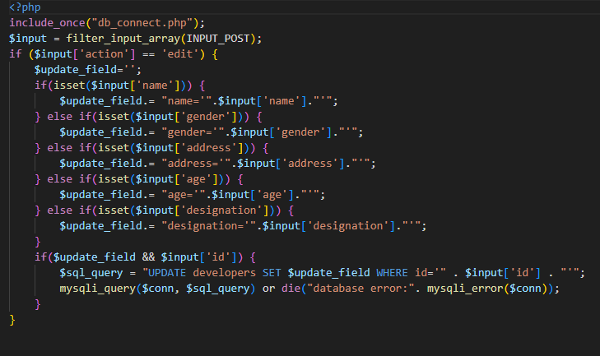**Live_edit.php :**

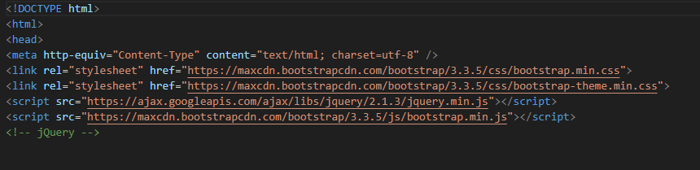 **Header.php :**

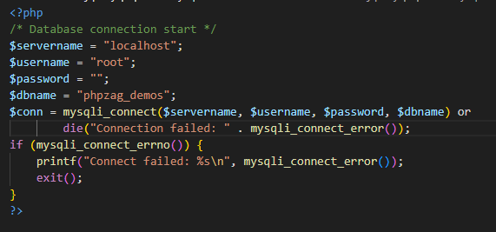 **Dbconnector.php :**

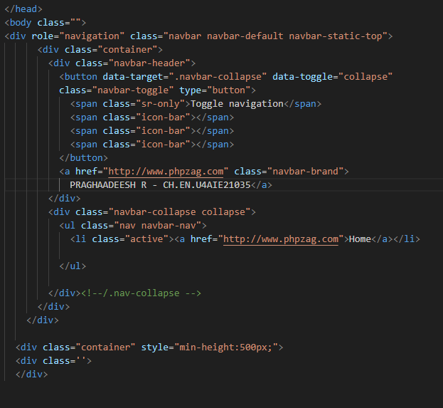 **Container.php :**

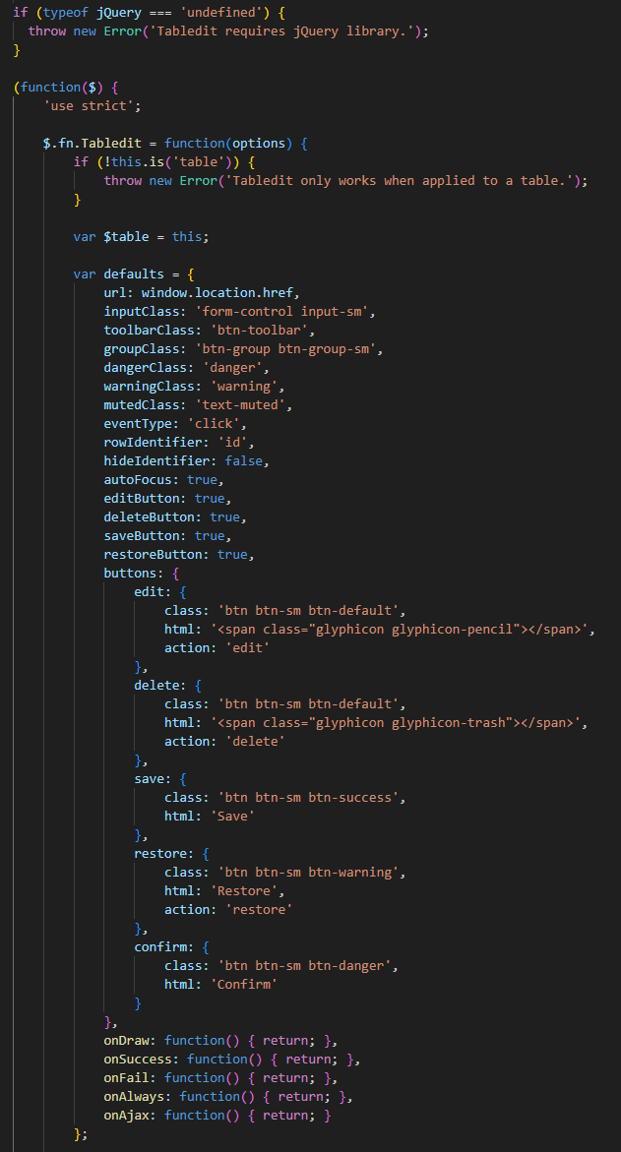 **Jquery.tabledit.js :**

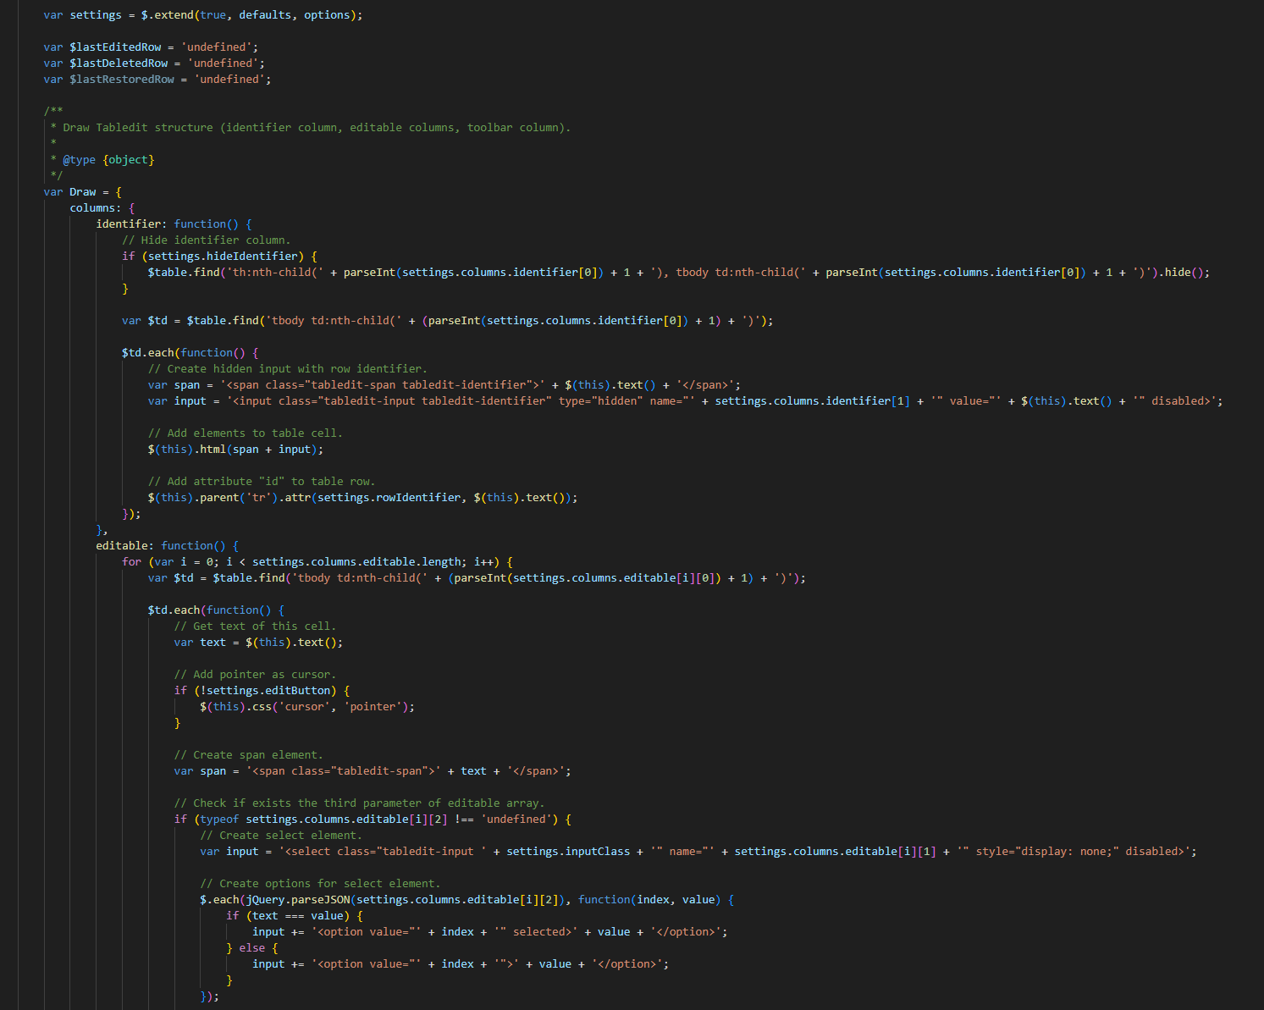

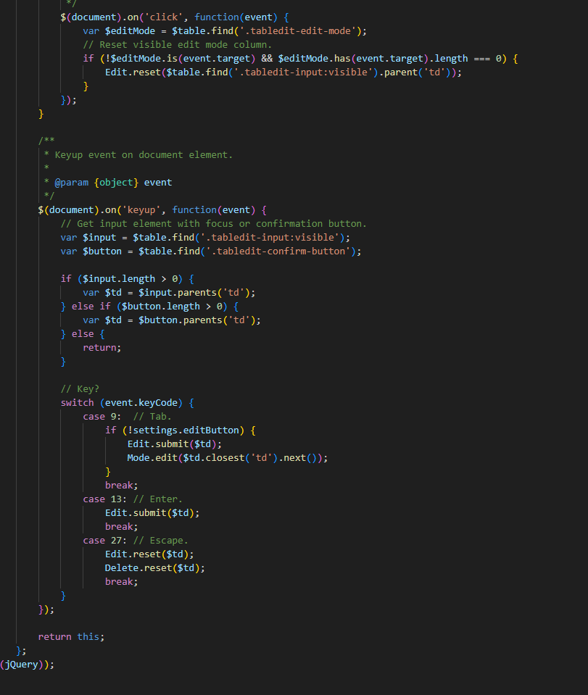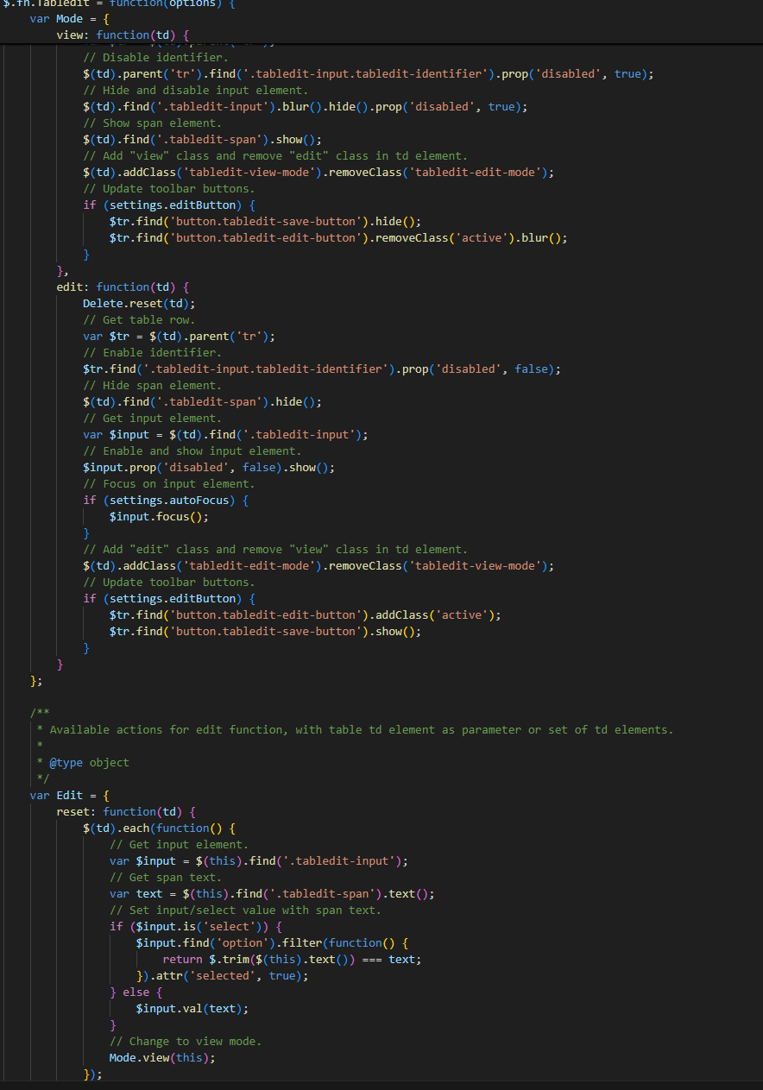

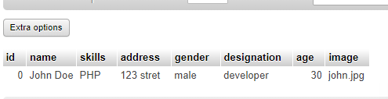**Entering value into MYSQL table :**

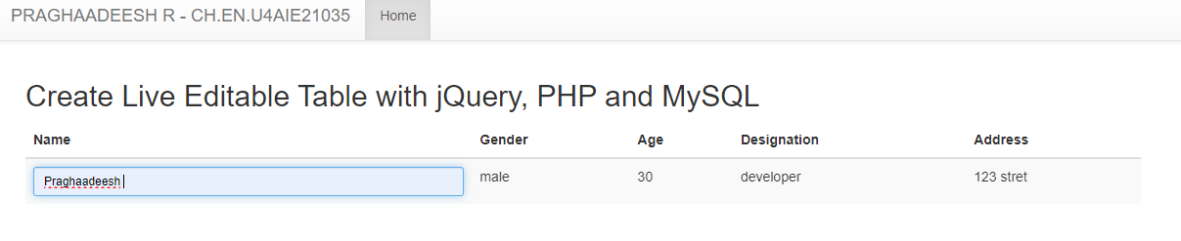**OUTPUT :**

**RESULT :**

Thus, a Live Editable Table with jQuery, PHP and MySQL has been created and the functionalities of the system has been verified.

**LAB-9**

**AIM :**

To Submit AJAX Forms with JQuery while also verifying data entered in form.

**PROCEDURE :**

**CODE :**

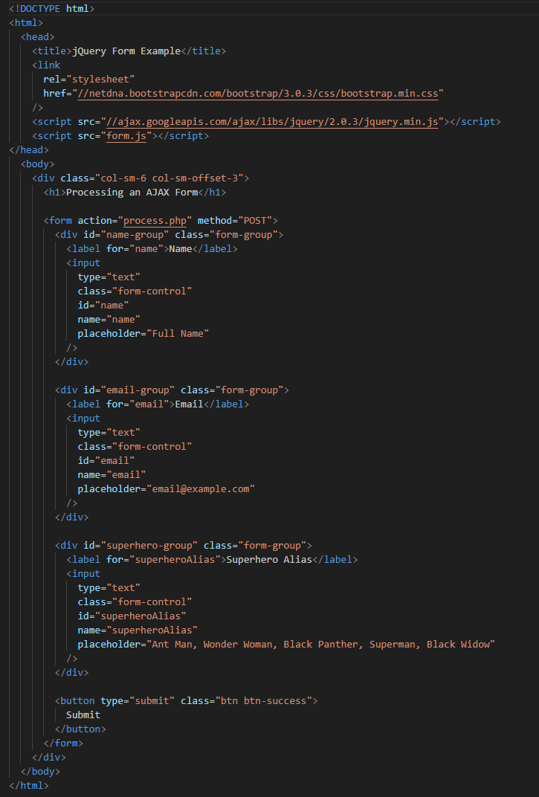 **Index.html :**

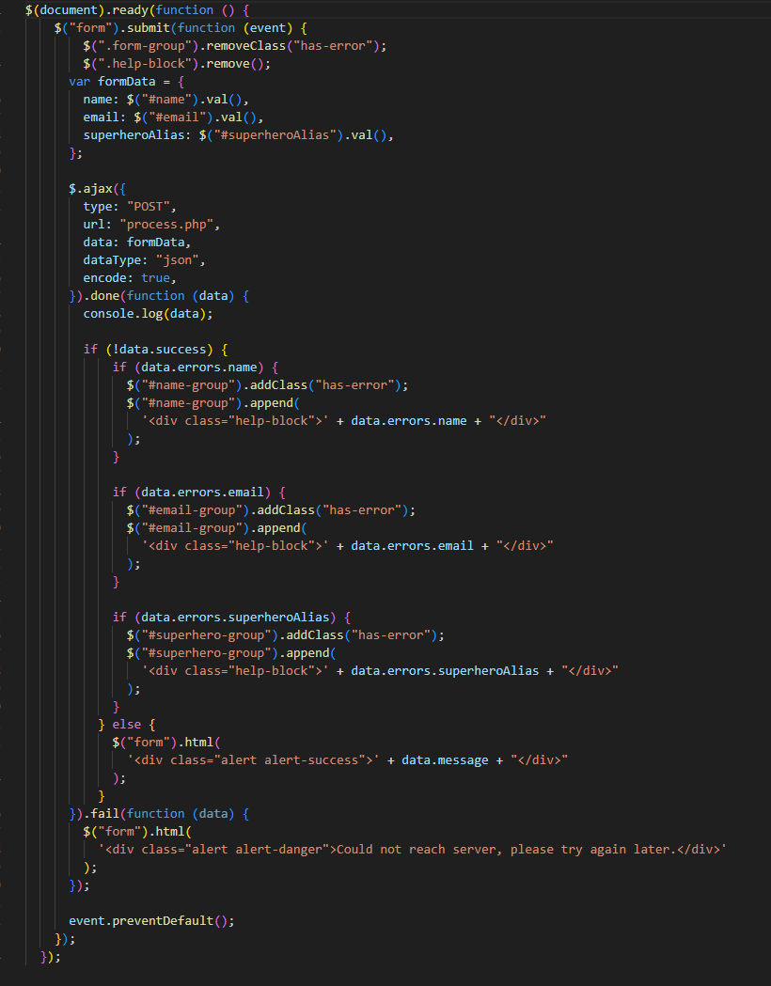 **Form.js :**

**Process.php :**

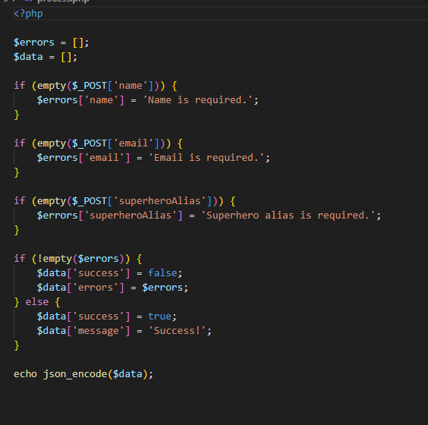

**OUTPUT :**

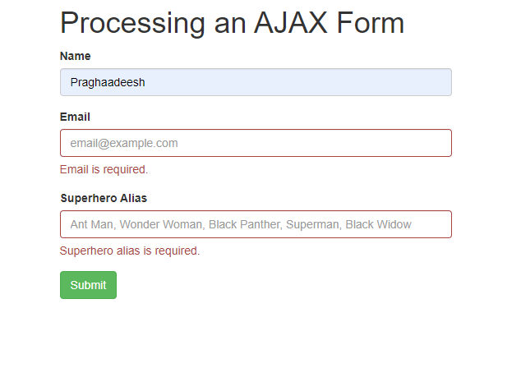 **When all details are not entered :**

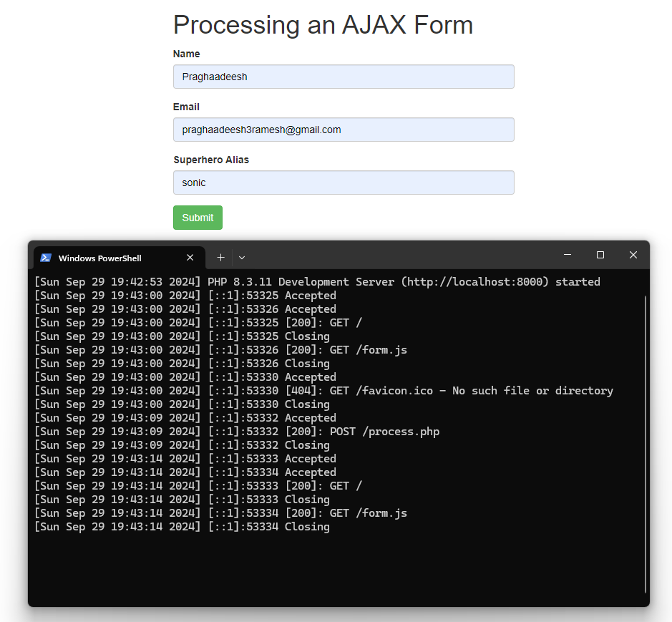 **When all details are entered :**

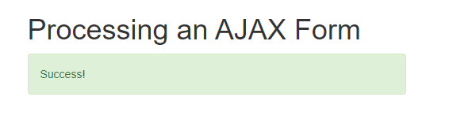

**RESULT :**

Thus, a AJAX Forms with JQuery has been created and the functionality has been verified.

**LAB-10**

**AIM :**

To perform AJAX Database Operations by creating a form for retrieving student data based on CGPA entered by the user into a ajax form.

**PROCEDURE :**

**CODE :**

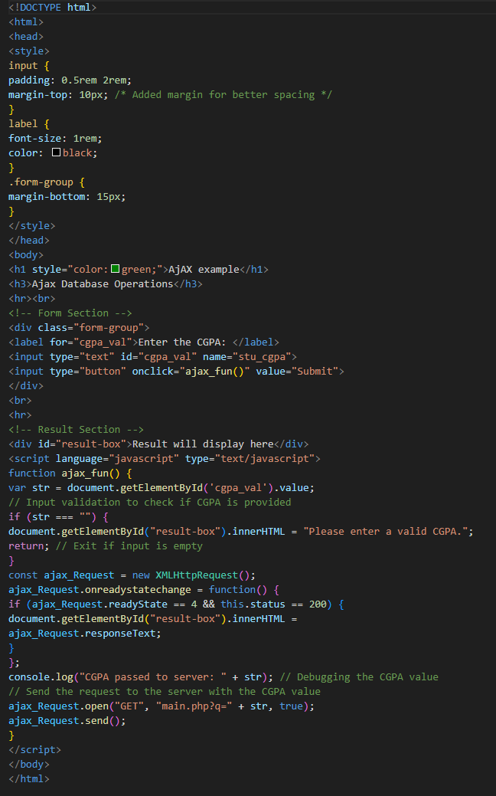 **Index.html :**

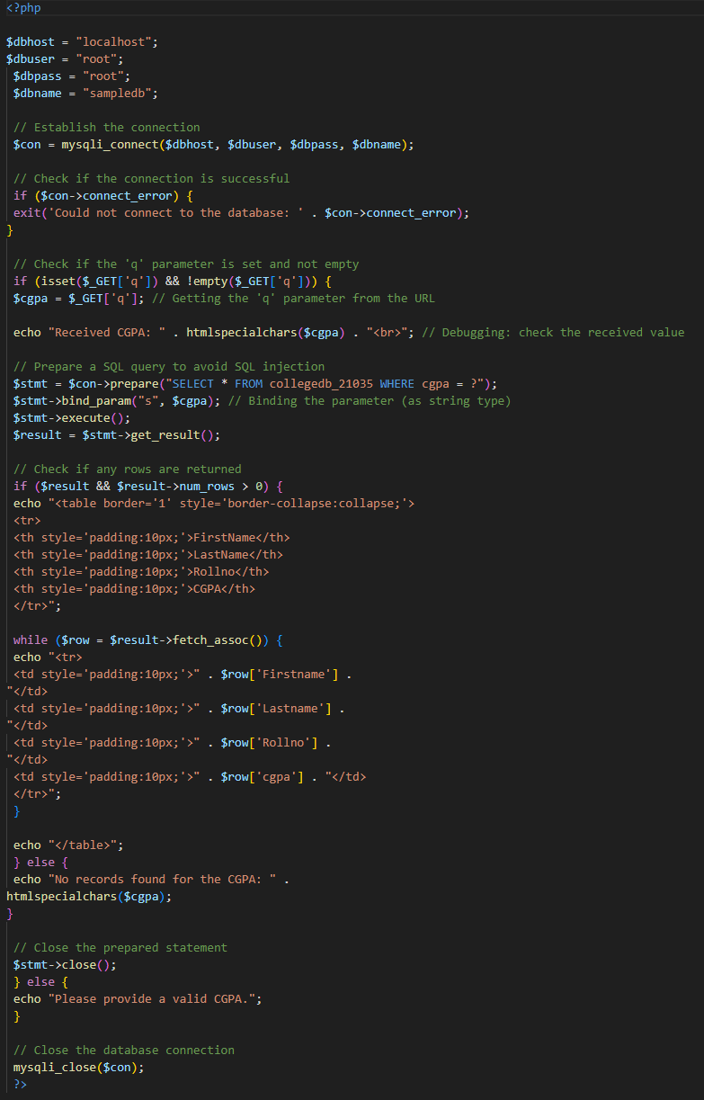 **Main.php :**

**Database entries :**

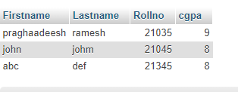

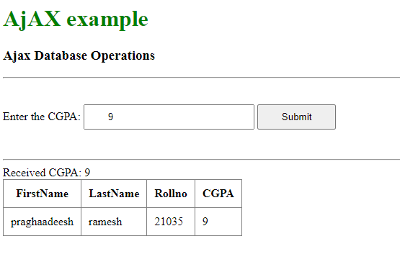 **OUTPUT :**

**RESULT :**

Thus, AJAX Database Operations have been performed on a student database to retrieve student data using CGPA entered by user.